### Table [Styles](Styles.docx)

Table [styles](styles.docx) are style definitions which apply to the contents of zero or more tables within a document. This definition may imply that the style can only define [table](table.docx) properties (properties which apply to the [table](table.docx) and its constituent rows and cells), however a [table](table.docx) style can also define paragraph properties (properties which apply to the positioning and appearance of paragraphs) as well as character properties (properties which apply to runs) for all of the paragraphs and runs within the specified [table](table.docx) in the document.

Table [styles](styles.docx) can only be referenced by tables within a document, and they must be referenced by the [tblStyle](tblStyle.docx) element (§) within a table’s [table](table.docx) properties.

As discussed above, [table](table.docx) [styles](styles.docx) can specify all of the properties that can be applied to a [table](table.docx), as well as paragraph and character properties for the table’s contents. However, unlike other style definitions, [table](table.docx) [styles](styles.docx) allow for the definition of conditional formats for different regions of the table.

These [table](table.docx) conditional formats are applied to different regions of the [table](table.docx) as follows:

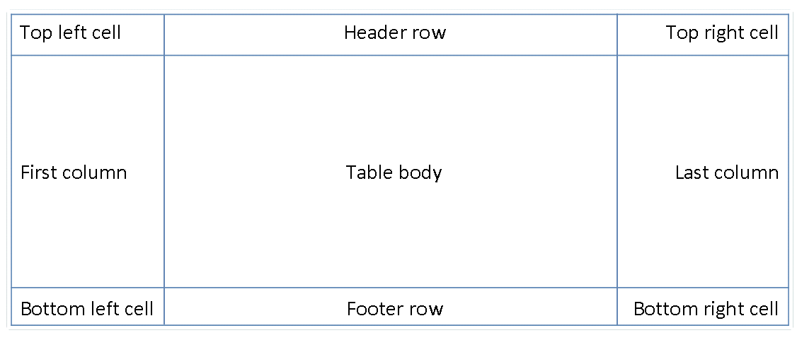

All rows in the [table](table.docx) can also have conditional formatting on an alternating row/column basis as well as follows:

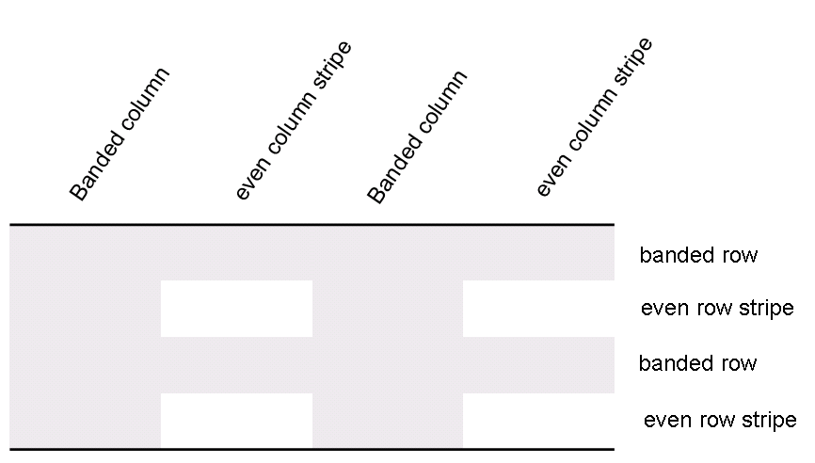

When specified, these conditional formats shall be applied in the following order (therefore subsequent formats override properties on previous formats):

* Whole [table](table.docx)
* Banded columns, even column banding
* Banded rows, even row banding
* First row, last row
* First [column](column.docx), last [column](column.docx)
* Top left, top right, bottom left, bottom right

[Example: Consider a [table](table.docx) style Test Table Style defined as follows:

* All cells with 1pt [table](table.docx) borders on all sides
* 0.1” cell margins on left and right of cells
* 0” cell margins on top and bottom of cells

As well as header row specific formatting of

* Red shading
* Bold [text](text.docx)

<w:style w:[type](type.docx)="[table](table.docx)" w:styleId="TestTableStyle">  
 <w:name w:val="Test Table Style"/>  
 <w:[basedOn](basedOn.docx) w:val="TableNormal"/>  
 <w:priority w:val="99"/>  
 <w:[rsid](rsid.docx) w:val="00340CC4"/>  
 <w:[tblPr](tblPr.docx)>  
 <w:[tblBorders](tblBorders.docx)>  
 <w:top w:val="single" w:[sz](sz.docx)="4" w:space="0" w:[color](color.docx)="auto"/>  
 <w:left w:val="single" w:[sz](sz.docx)="4" w:space="0" w:[color](color.docx)="auto"/>  
 <w:bottom w:val="single" w:[sz](sz.docx)="4" w:space="0" w:[color](color.docx)="auto"/>  
 <w:right w:val="single" w:[sz](sz.docx)="4" w:space="0" w:[color](color.docx)="auto"/>  
 <w:[insideH](insideH.docx) w:val="single" w:[sz](sz.docx)="4" w:space="0" w:[color](color.docx)="auto"/>  
 <w:[insideV](insideV.docx) w:val="single" w:[sz](sz.docx)="4" w:space="0" w:[color](color.docx)="auto"/>  
 </w:[tblBorders](tblBorders.docx)>  
 <w:[tblCellMar](tblCellMar.docx)>  
 <w:top w:[w](w.docx)="0" w:[type](type.docx)="dxa"/>  
 <w:left w:[w](w.docx)="108" w:[type](type.docx)="dxa"/>  
 <w:bottom w:[w](w.docx)="0" w:[type](type.docx)="dxa"/>  
 <w:right w:[w](w.docx)="108" w:[type](type.docx)="dxa"/>  
 </w:[tblCellMar](tblCellMar.docx)>  
 </w:[tblPr](tblPr.docx)>  
 <w:[tblStylePr](tblStylePr.docx) w:[type](type.docx)="firstRow">  
 <w:[rPr](rPr.docx)>  
 <w:[b](b.docx)/>  
 </w:[rPr](rPr.docx)>  
 <w:[tcPr](tcPr.docx)>  
 <w:[shd](shd.docx) w:val="clear" w:[color](color.docx)="auto" w:fill="ED1C24"/>  
 </w:[tcPr](tcPr.docx)>  
 </w:[tblStylePr](tblStylePr.docx)>  
</w:style>

The [tblPr](tblPr.docx) element holds the formatting which is applied to the entire [table](table.docx), and the [tblStylePr](tblStylePr.docx) element with a [type](type.docx) attribute value of firstRow holds the formatting for the first [table](table.docx) row, specifically the bold run property and red cell shading. end example]

An individual instance of a [table](table.docx) defines an association with a [table](table.docx) style using the [tblStyle](tblStyle.docx) element in the table’s properties ([tblPr](tblPr.docx)), as discussed above. However, individual tables can choose whether to apply the following aspects of the table’s conditional formats individually:

* First row
* Last row
* First [column](column.docx)
* Last [column](column.docx)
* Row banding
* Column banding

The use or omission conditional formats shall be specified using the [tblLook](tblLook.docx) element, which contains a bitmask representing which properties are applied and omitted.

[Example: Consider two tables using the [table](table.docx) style Style2; one which specifies that it should only use the header row and footer row conditional formatting properties from the [table](table.docx) style, and the other which specifies that it should use the header row, footer row, and banded row conditional formatting:

<w:[tbl](tbl.docx)>

<w:[tblPr](tblPr.docx)>

<w:[tblStyle](tblStyle.docx) w:val="Style2"/>

<w:[tblW](tblW.docx) w:[w](w.docx)="0" w:[type](type.docx)="auto"/>

<w:[tblLook](tblLook.docx) w:val="0660"/>

</w:[tblPr](tblPr.docx)>

…

</w:[tbl](tbl.docx)>

…

<w:[tbl](tbl.docx)>

<w:[tblPr](tblPr.docx)>

<w:[tblStyle](tblStyle.docx) w:val="Style2"/>

<w:[tblW](tblW.docx) w:[w](w.docx)="0" w:[type](type.docx)="auto"/>

<w:[tblLook](tblLook.docx) w:val="0460"/>

</w:[tblPr](tblPr.docx)>

…

</w:[tbl](tbl.docx)>

The tables each specify the appropriate set of conditional formats using the [tblLook](tblLook.docx) element, as seen by the identical [table](table.docx) [styles](styles.docx) in the [tblStyle](tblStyle.docx) element, and different [tblLook](tblLook.docx) values. end example]